Tensor Completion for Estimating Missing Values in Visual Data

Akhperjanyants Georgiy   
Dept. of Electrical Engineering  
Binghamton University

*Abstract*—In this paper I compare the effectiveness of three different low rank tensor completion algorithms by comparing the relative square error (RSE) and visually. The algorithms extend the idea of low rank matrix completion based on the matrix trace norm to the tensor case. The problem is one of convex optimization and is much harder to solve in the straightforward way than its matrix counterpart because of the dependencies among several constraints. The Simple Low Rank Tensor Completion (SiLRTC) algorithm uses the block coordinate descent strategy to tackle this problem and arrive at an optimal solution. The Fast Low Rank Tensor Completion (FaLRTC) algorithm takes the original non-smooth problem and uses a smoothing technique to solve it. The High Accuracy Low Rank Tensor Completion (HaLRTC) uses the ADMM (alternating direction method of multiplier) technique to solve the non-smooth problem. The TMac-TT (parallel matrix factorization in the concept of tensor train) algorithm converts the problem into a matrix factorization of the given image tensor.

# **Introduction**

Tensor completion has applications in computer vision, graphics, and in any other case where estimation of 3-D (or larger) missing values is required. At the core of this approach is the assumption that the missing values have a high degree of dependency amongst each other and that the further apart they are the smaller the dependencies. However missing entries can also be dependent on entries that are not close to them, therefore it is important to be able to capture information on a global scale about a given set of data. The rank and trace norm functions are able to provide global data but the “rank” function is not convex. The trace norm leads to a convex optimization problem and is actually the tightest convex approximation for the rank of matrices. The definition of the trace norm for tensors is:

${\left\|X\right\|}_{*}=\sum_{i=1}^{n}{α_{i}{\left\|X_{\left(i\right)}\right\|}_{*}}$ (1)

Where 𝛴αi =1. This formulation is basically just a convex combination of the trace norm of the matrices that result when the tensor 𝒳 is unfolded along each of its modes. The tensor completion problem is then formulated in the following way:

$min\underset{X}{:}\begin{aligned}\sum_{i=1}^{n}{α_{i}{\left\|X_{\left(i\right)}\right\|}_{*}} \\ s.t.:X_{Ω}=T_{Ω}\end{aligned}$ (2)

Where 𝛺 is the set of indices of the known entries of the image being processed.

# **Role of SVD, truncate, and shrinkage operations**

The basis for all the algorithms discussed in this paper is the Singular Value Decomposition (SVD) which produces the following result when performed on a matrix M:

$SVD\left(M\right)=UΣV$ (3)

Where U and V are unitary matrices and 𝛴 is a diagonal matrix of the singular values of M.

The truncate operation is defined as:

$T_{τ}\left(M\right)=UΣ_{\overset{´}{τ}}V$ (4)

The shrinkage operation is defined as:

$D_{τ}\left(M\right)=UΣ_{τ}V$ (5)

Where $Σ_{\overset{´}{τ}}=diag\left(min\left(σ_{i},τ\right)\right)$ and $Σ_{τ}=diag\left(max\left(σ_{i}-τ,0\right)\right)$.

The truncate and shrinkage operators are used to solve the minimization and maximization techniques in the four aforementioned algorithms.

# **The Simple Low Rank Tensor Completion Algorithm (SiLRTC)**

An effective way to solve the problem in equation (2) is to split the interdependent terms of the tensor 𝒳 into several matrices M1…Mn and reformulate it into the following problem:

$min\underset{X,M_{i}}{:}\begin{aligned}\sum_{i=1}^{n}{α_{i}{\left\|X_{\left(i\right)}\right\|}_{*}}+\frac{β_{i}}{2}{\left\|X_{\left(i\right)}-M_{i}\right\|}_{F}^{2} \\ s.t.:X_{Ω}=T_{Ω}\end{aligned}$ (6)

Where *βi*’s are positive real numbers and ||.||F is the Frobenius norm. Equation (6) can be solved by the block coordinate descent method. This method optimizes one group of variables while keeping all the other groups fixed. The variables are separated into *n+1* blocks: *𝒳, M1, …, Mn.* The optimal *𝒳* is determined by solving the sub-problem:

$min\underset{X}{:}\begin{aligned}\sum_{i=1}^{n}{\frac{β_{i}}{2}{\left\|X_{\left(i\right)}-M_{i}\right\|}_{F}^{2}} \\ s.t.:X_{Ω}=T_{Ω}\end{aligned}$ (7)

Whose solution is given by:

$X_{i_{1,…,i_{n}} }= \left\{\begin{aligned}({\frac{\sum_{i}{β_{i}}{fold}_{i}\left(M_{i}\right)}{\sum_{i}{β_{i}}})}_{i_{1},…,i_{n}} for \left(i_{1,….,}i_{n}\right)\text{∉}Ω \\ T_{i_{1,…,i_{n}} } for \left(i_{1,….,}i_{n}\right)\text{∈}Ω\end{aligned}\right.$ (8)

The optimal solution for *Mi* is given by:

$D_{τ}\left(X_{\left(i\right)}\right),τ=\frac{α_{i}}{β_{i}}$ (9)

# **The Fast Low Rank Tensor Completion Algorithm (FaLRTC)**

The FaLRTC converts the non-smooth problem of computing the tensor trace norm into a smooth problem and uses the solution to this smooth problem to approximate the non-smooth one. It also improves the speed of convergence. The non-smooth trance norm term defined by equation (2) is converted into a smooth version by using the trace norm dual and subtracting a strongly convex function from the dual:

$f_{μ}\left(X\right)=f_{0}\left(X\right)+\sum_{i=1}^{n}{\begin{aligned}max \\ \left\|Y_{i\left(i\right)}\right\|≤1\end{aligned}}α_{i}\left\langle X,Y_{i}\right\rangle -\frac{μ_{i}}{2}{\left\|Y_{i}\right\|}_{F}^{2}$ (10)

Where 𝒴1,…,n are the n dual tensors and µi’s are positive constants.

The gradient of equation (10) can be computed by the truncate operation:

${∇f}_{μ}\left(X\right)=\left\{\begin{aligned}{\left(\sum_{i=1}^{n}{\frac{α_{i}^{2}}{μ_{i}}T_{\frac{μ_{i}}{α_{i}}\left(X_{\left(i\right)}\right)}}\right)}_{i_{1},...,i_{n}},\left(i_{1},...,i_{n}\right)\text{∉}Ω \\ 0,\left(i_{1},...,i_{n}\right)∈Ω\end{aligned}\right.$ (11)

# **The High Accuracy Low Rank Tensor Completion Algorithm (HaLRTC)**

This algorithm is uses the alternating direction method of multipliers (ADMM) framework to solve the same problem posed by equation (2). Equation (2) becomes:

$min\underset{X,M_{1},...,M_{n}}{:}\begin{aligned}\sum_{i=1}^{n}{α_{i}{\left\|M_{i\left(i\right)}\right\|}_{*}} \\ s.t.:X_{Ω}=T_{Ω} \\ X=M_{i},i=1,...,n\end{aligned}$ (12)

The augmented Lagrangian function is defined as:

$L_{ρ}=\left(X,M_{1},...,M_{n},Y_{1},...,Y_{n}\right)=\sum_{i=1}^{n}{α_{i}{\left\|M_{\left(i\right)}\right\|}_{}+\left\langle X-M_{i},Y_{i}\right\rangle +\frac{ρ}{2}}{\left\|X-M_{i}\right\|}_{F}^{2}$ (13)

The 𝓜i’s, 𝒴*i*’s and 𝒳 are iteratively updated to obtain closed form solutions for determining which 𝓜 and 𝒳 give the minimum result over the convex set $Q=\{X∈R^{I_{1}×I_{2}×...×I_{n}}∨X_{Ω}=T_{Ω}\}$.

# **Tensor Completion by Parallel Matrix Factorization in the Concept of Tensor Train (TMac-TT)**

This algorithm was not covered in the original paper, instead I found it in a paper titled “Efficient Tensor Completion: Low Rank Tensor Train” [1]. It addresses the tensor completion problem by tensor train rank optimization:

$min\underset{X_{\left(i\right)}}{:}\begin{aligned}\sum_{i=1}^{n-1}{α_{i}rank\left(X_{\left(i\right)}\right)} \\ s.t.:X_{Ω}=T_{Ω}\end{aligned}$ (14)

This optimization problem is broken down into a factorization model $X_{\left(i\right)}=UV$, where $X_{\left(i\right)}∈R^{m×n}$ of rank *ri* and $U∈R^{m×r_{i}},V∈R^{r_{i}×n}$

$\sum_{i=1}^{n-1}{\frac{α_{i}}{2}{\left\|{U_{i}V_{i}-X}_{\left(i\right)}\right\|}_{F}^{2}} s.t.:X_{Ω}=T_{Ω}$ (15)

# **Results**

The Relative Square Error (RSE) metric is used

to evaluate the performance of each algorithm. RSE is defined as:

$RSE = \frac{{\left\|X - T\right\|}_{F}}{{\left\|T\right\|}_{F}}$ (16)

The results for FaLRTC are not given here because of an error in my implementation that results in output being the same noisy input image. I am unable to figure out why this is happening.

I chose four images with 50, 75, and 85% of the pixel values missing.

Original Images:

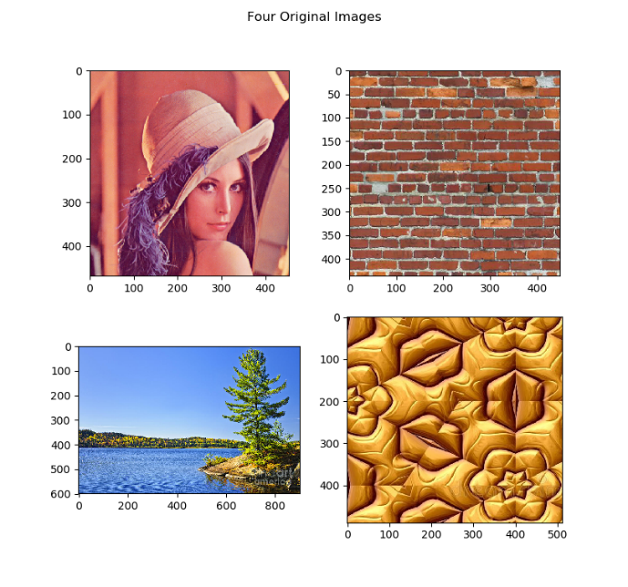

**Fig. 1**

Images with noise:

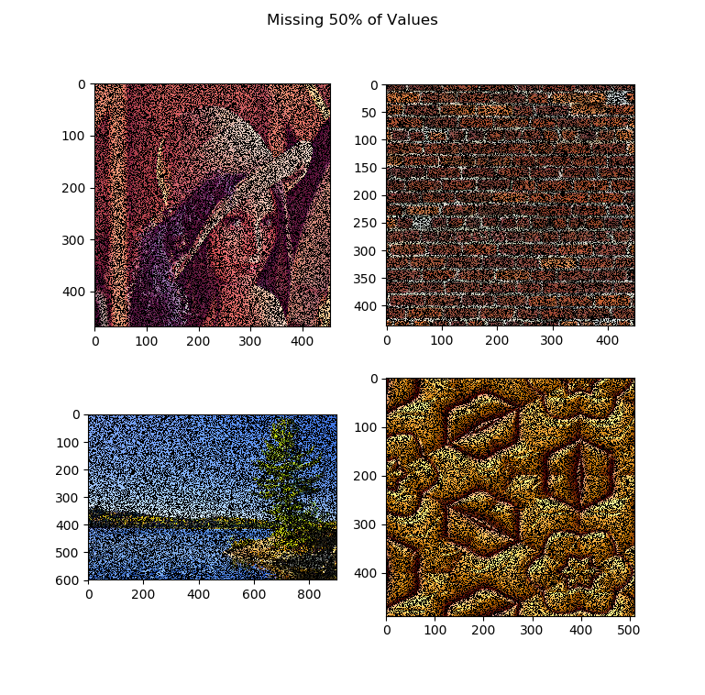**Fig. 2**

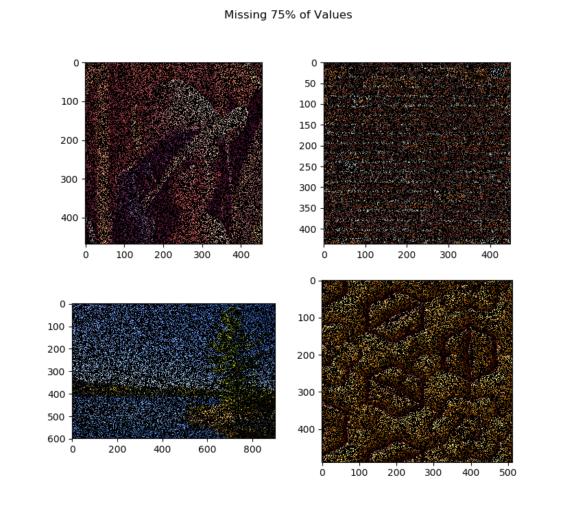**Fig. 3**

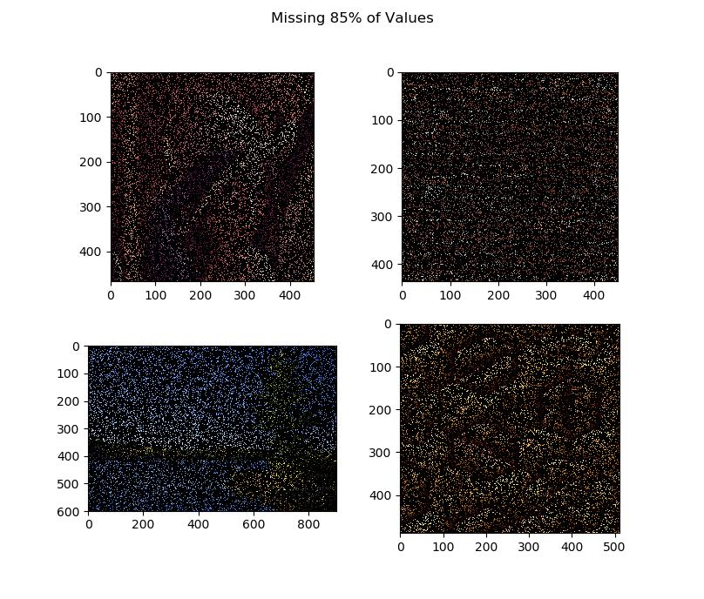

**Fig. 4**

SiLRTC: I ran each of the 4 images through 16, 32, 64, and 128 iterations with 50%, 75%, and 85% of image missing in the image

RSE results for SiLRTC:

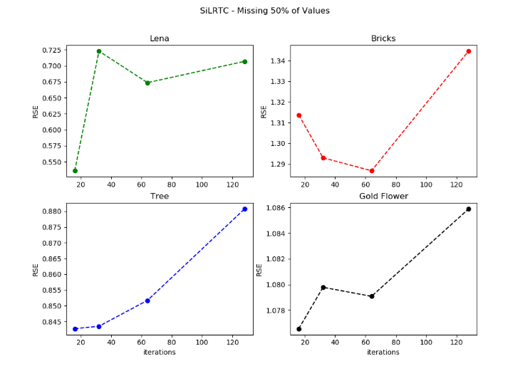

**Fig. 5**

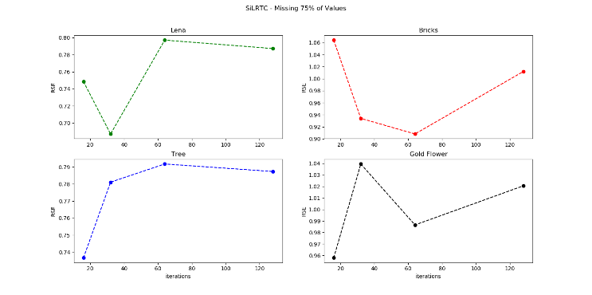

**Fig. 6**

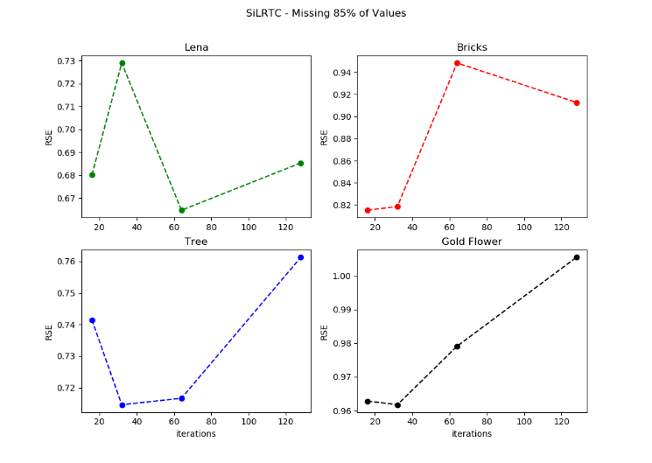

**Fig. 7**

Visual results for SiLRTC:

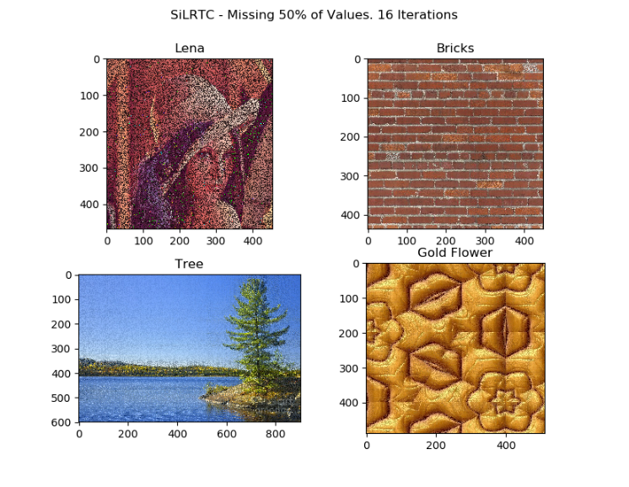

**Fig. 8**



**Fig. 9**

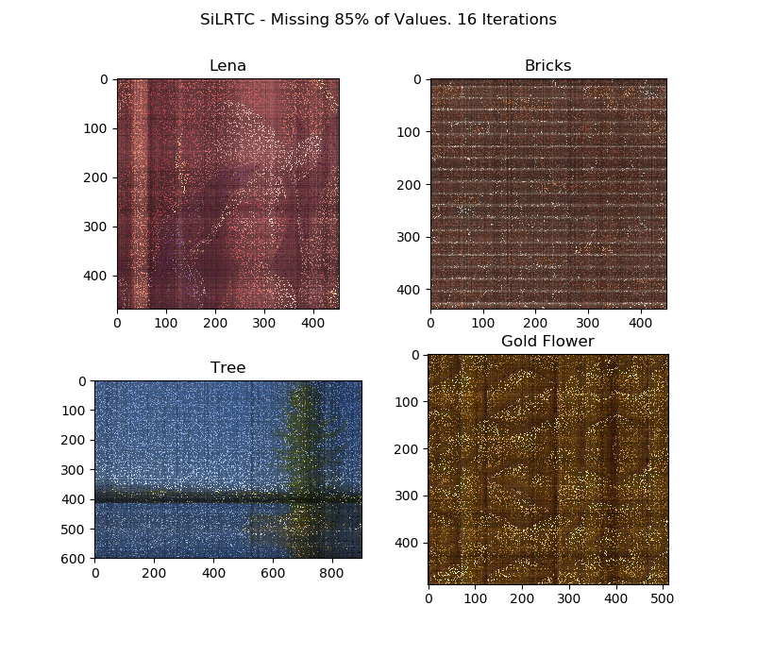

**Fig. 10**

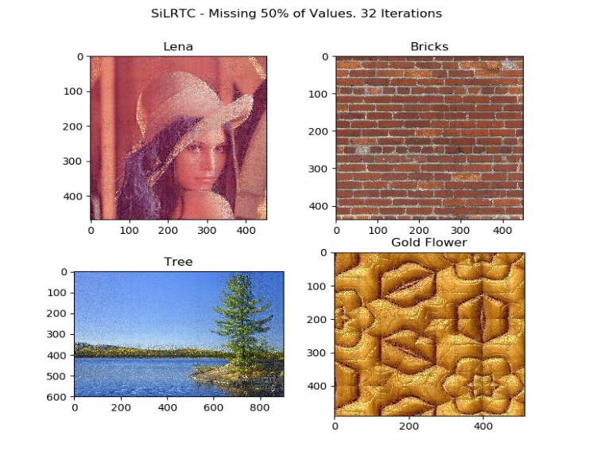

**Fig. 11**

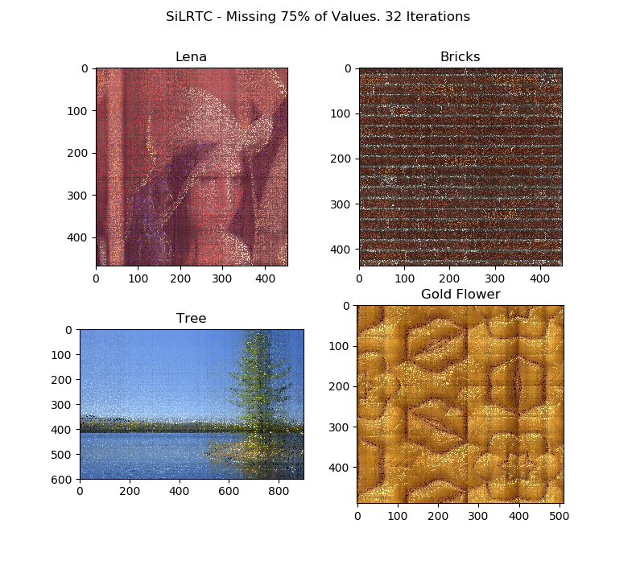

**Fig. 12**

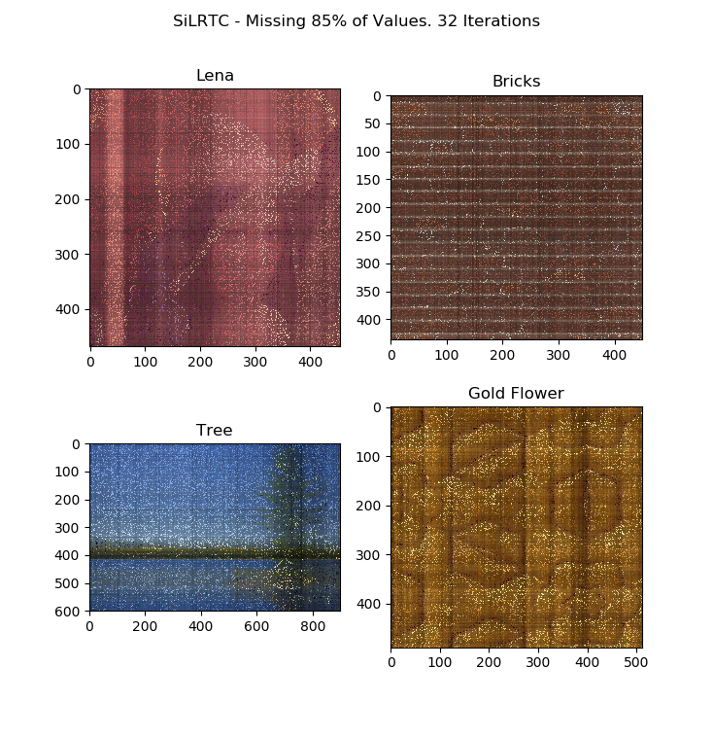

**Fig. 13**

For SiLRTC the RSE graphs show that the error is increasing for a given percentage of noise over an increasing amount of iterations, however from a visual observation the images appear to look more like their original counterparts after an increase in the number of iterations. This could be due to the fact that numerically the pixel values have a greater difference between the estimated and original but to the human eye this is not noticeable and results in an image that actually looks more like the original.

For Tmac-TT I ran 100, 168, 256, and 300 iterations on the four images above.

RSE Results for TMac-TT:

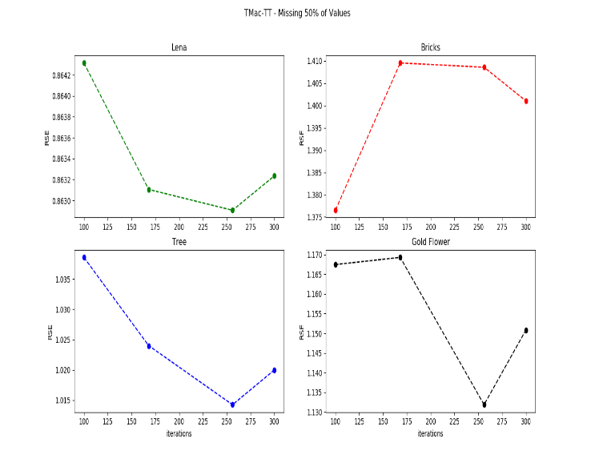**Fig. 14**

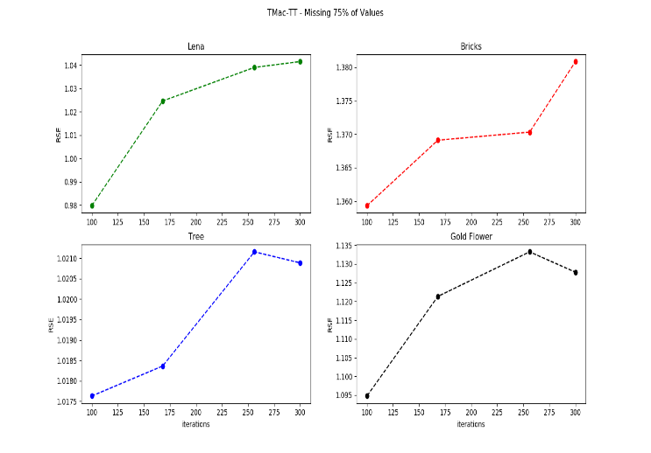**Fig. 15**

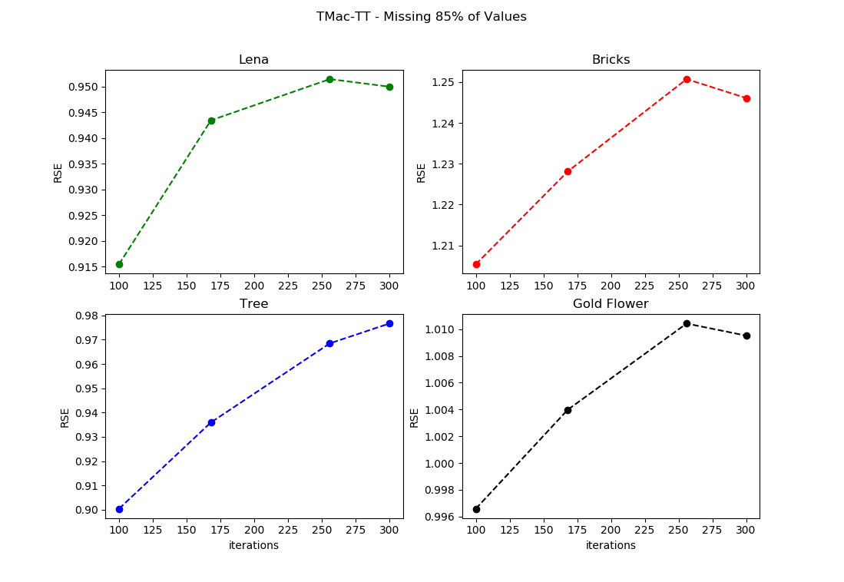**Fig. 16**

Visual results for TMac-TT:

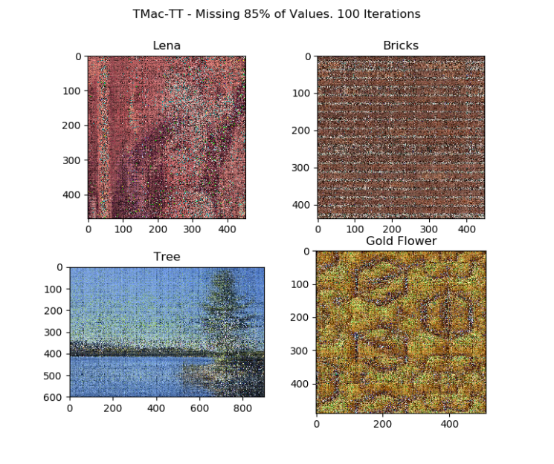

**Fig. 17**

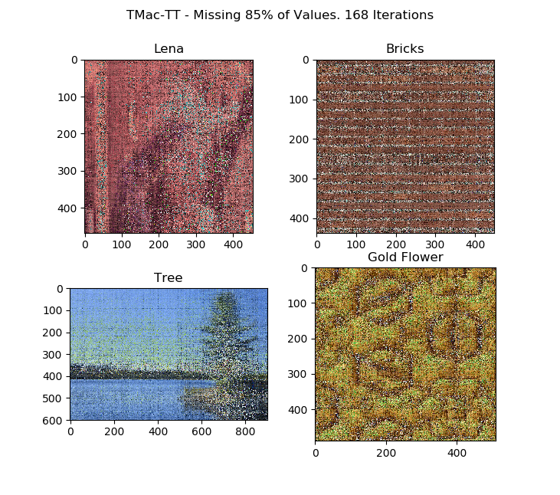

**Fig. 18**

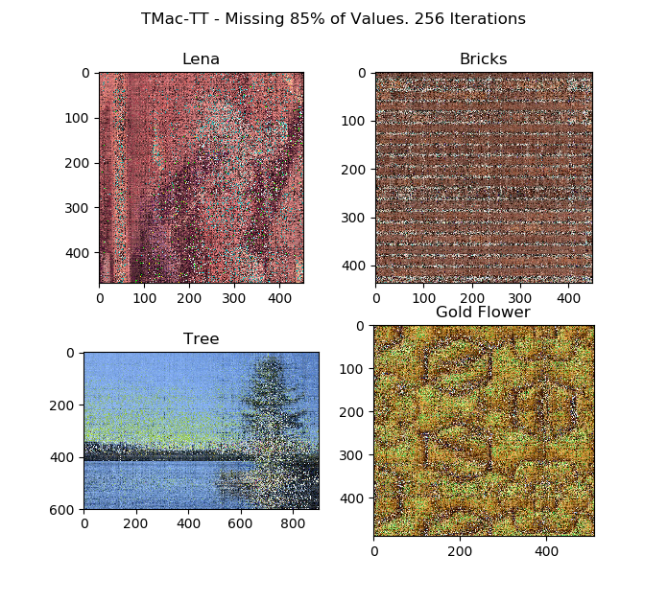

**Fig. 19**

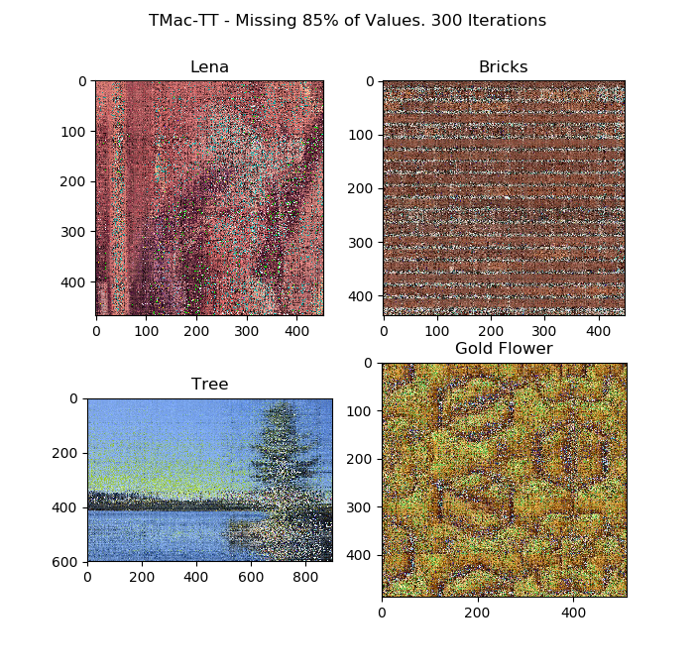

**Fig. 20**

I got unexpected results for the TMAc-TT algorithm because the RSE is above 1, this means that every pixel in the image was somehow altered. I am unable to come up with an explanation for why this happened other than an error in the implementation of this algorithm.

I did not provide the visual results for the HaLRTC algorithm, but they are included in the report submission.

RSE results for HaLRTC:

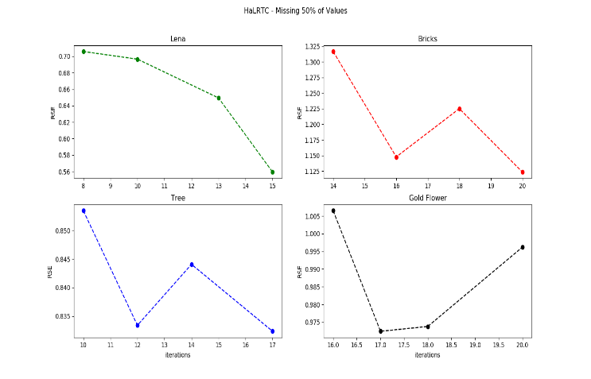

**Fig. 21**

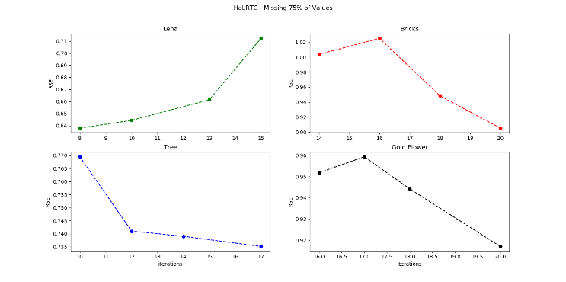

**Fig. 22**

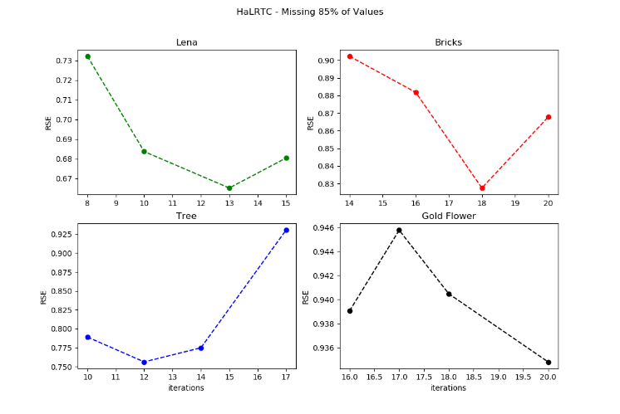

**Fig. 23**

The RSE gets larger in most cases for bigger iterations of this algorithm.

The results I obtained from the three working algorithms were not as good as the results obtained in the original paper. I had a lot of difficulty picking the correct µ’s, α’s, and ρ’s. Picking the correct constants is the key to these algorithms working properly. These algorithms also seem to work better with images that have some kind of uniform structure

##### References

1. Johann A. Bengua, Ho N. Phien, Hoang D. Tuan, Minh N. Do, “Efficient tensor completion for color image and video recovery: Low-rank tensor train,” *IEEE Transactions on Image Processing*, Vol 26, Issue 5, pp 2466-2479, 2017.